# Software Testing and Quality – Lab 5

## Python Code

# importing webdriver from selenium

from selenium import webdriver

from selenium.webdriver.common.by import By

from selenium.common.exceptions import NoSuchElementException

from selenium.webdriver.common.keys import Keys

# method to check a link text is available in home page or not

def checkAvailLinkText(url_text):

    try:

        driver.find_element(By.LINK_TEXT,url_text)

        print("An URL is available for given text",url_text)

    except NoSuchElementException:

        print("The given",url_text,"is not found")

# Chrome web browser will be used

driver = webdriver.Chrome()

# assign university URL and open it using driver

univURL="https://www.lewisu.edu/"

driver.get(univURL)

# retrieve the title of the page and check it

title=driver.title

if(title=="Lewis University"):

    print("The University Webiste contains the title as Lewis University")

else:

    print("The University Website does not contains the title as Lewis University")

# method calls to check the link text is available in the home page or not

checkAvailLinkText("About Us")

checkAvailLinkText("Academics")

checkAvailLinkText("Admission & Aid")

checkAvailLinkText("Athletics")

checkAvailLinkText("Student Life")

checkAvailLinkText("Locations")

# retrieve the URL of the faculty or staff link

url_fac_staff=driver.find_element(By.LINK_TEXT,"Fac/Staff").get_attribute('href')

print("URL",url_fac_staff)

input("Enter a key to navigate to the Fac/Staff directory from home page")

driver.get(url_fac_staff)

# search the text Omari in the university web site and displays the result

input("Enter a key to search Omari and display result")

driver.get("https://www.lewisu.edu/facstaffdirectory/FacStaffDir2.htm")

searchBox = driver.find_element(By.NAME,"last")

searchBox.send_keys("Omari")

searchBox.send_keys(Keys.RETURN)

## Output

### Home Page of University Website

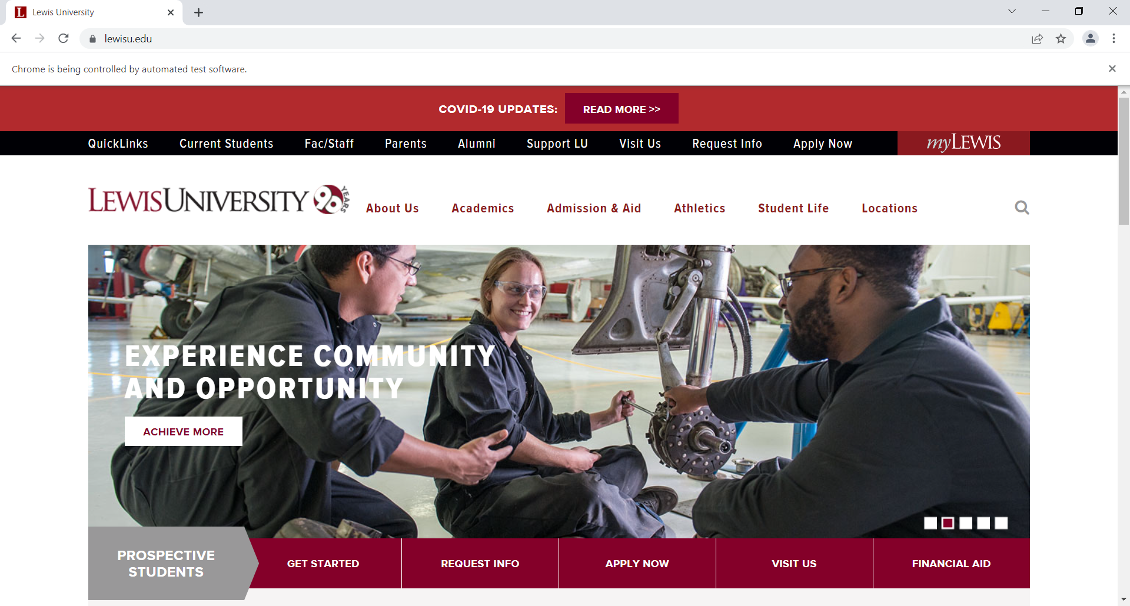

### Checking University Title



### Checking the given link in Home Page

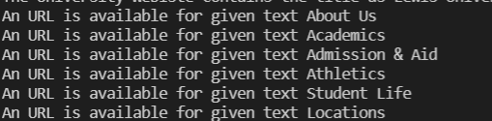

### Navigating the home page to Fac/Staff directory

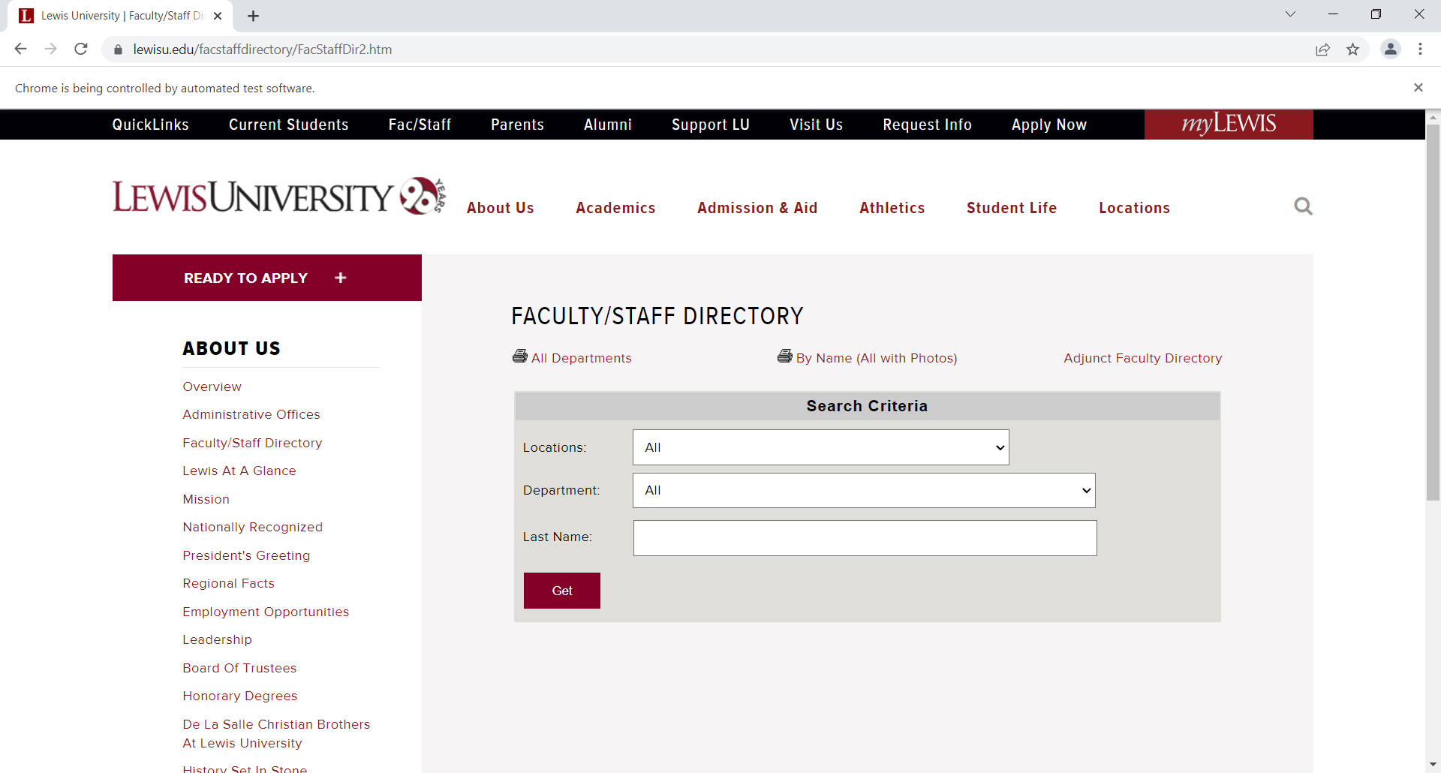

### Search for the text “Omari” and displays the result

